UNIT 2
EXPERIMENT 1:
CODE:
# Create the data frame
Age <- c("5-6", "7-8", "9-10")
A <- c(18, 2, 20)
B <- c(22, 28, 10)
C <- c(20, 40, 40)
photo_data <- data.frame(Age, A, B, C)
# Display the data
print(photo_data)
# 1. Sample covariance between B and C
cov_BC <- cov(photo_data$B, photo_data$C)
cat("Sample Covariance between B and C:\n")
print(cov_BC)
# 2. Sample covariance matrix for A, B, and C
cov_matrix <- cov(photo_data[, c("A", "B", "C")])
cat("\nSample Covariance Matrix:\n")
print(cov_matrix)
# 3. Sample correlation between B and C
cor_BC <- cor(photo_data$B, photo_data$C)
cat("\nSample Correlation between B and C:\n")
print(cor_BC)
# 4. Sample correlation matrix for A, B, and C
cor_matrix <- cor(photo_data[, c("A", "B", "C")])
cat("\nSample Correlation Matrix:\n")
print(cor_matrix)
OUTPUT:
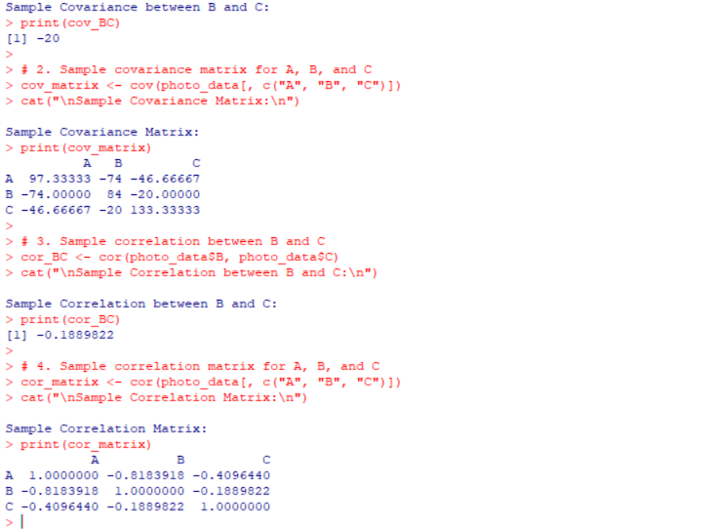
EXPERIMENT 2:
CODE:
# Input data
data <- c(
1, 1, 5, 5, 5, 5, 5, 8, 8, 10, 10, 10, 10, 12,
14, 14, 14, 15, 15, 15, 15, 15, 18, 18, 18, 18, 18,
20, 20, 20, 20, 20, 20, 21, 21, 21, 21,
25, 25, 25, 25, 25, 28, 28, 30
)
# Display original data
cat("Original Data:\n")
print(data)
# Equal-frequency partitioning into 3 bins
bins <- split(data, cut(seq_along(data), 3, labels = FALSE))
cat("\nEqual Frequency Bins:\n")
print(bins)
# -------------------------
# Bin Means Smoothing
# -------------------------
bin_means <- lapply(bins, function(x) rep(mean(x), length(x)))
cat("\nBin Means Smoothing:\n")
print(bin_means)
# -------------------------
# Bin Boundary Smoothing
# -------------------------
bin_boundary <- lapply(bins, function(x) {
lower <- min(x)
upper <- max(x)
sapply(x, function(v) {
if ((v - lower) <= (upper - v))
lower
else
upper
})
})
cat("\nBin Boundary Smoothing:\n")
print(bin_boundary)
# -------------------------
# Histogram
# -------------------------
hist(data,
breaks = 10,
col = "lightblue",
main = "Histogram of Electronics Prices",
xlab = "Price",
OUTPUT 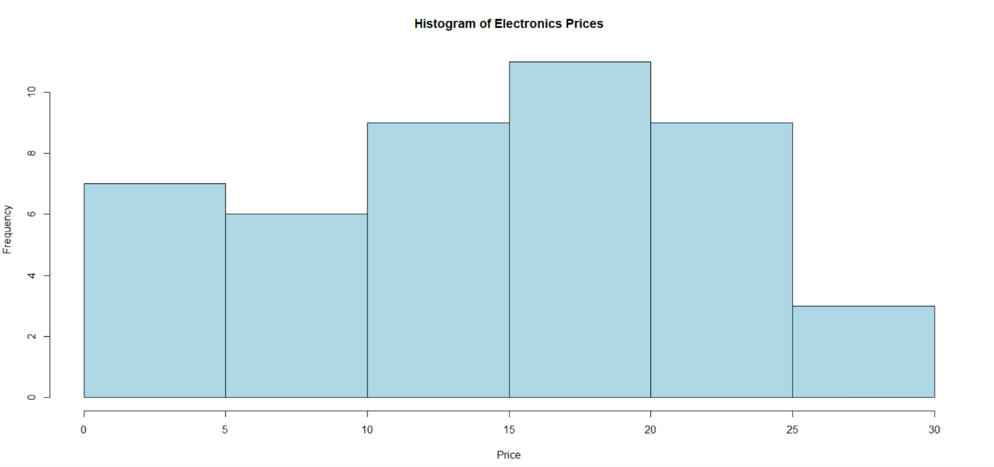
EXPERIMENT 3:
CODE:
A <- c(76,35,47,64,95,66,89,36,84)
B <- c(51,56,84,60,59,70,63,66,50)
cat("Mean of Class A =", mean(A), "\n")
cat("Mean of Class B =", mean(B), "\n\n")
cat("Median of Class A =", median(A), "\n")
cat("Median of Class B =", median(B), "\n\n")
cat("Range of Class A =", diff(range(A)), "\n")
cat("Range of Class B =", diff(range(B)), "\n")
boxplot(A, B,
names = c("Class A","Class B"),
col = c("lightblue","lightgreen"),
main = "Boxplot of Class A and Class B",
ylab = "Marks")
OUTPUT:
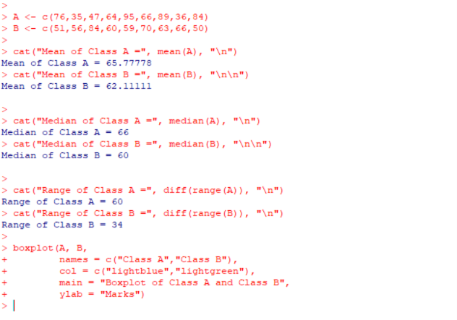

EXPERIMENT 4:
CODE:
# Data
x <- c(200,300,400,600,1000)
# (a) Min-Max Normalization
minmax <- (x - min(x)) / (max(x) - min(x))
print(minmax)
# (b) Z-Score Normalization
zscore <- (x - mean(x)) / sd(x)
print(zscore)
min <- 50000
max <- 100000
v <- 80000
result <- (v - min) / (max - min)
print(result)
OUTPUT:
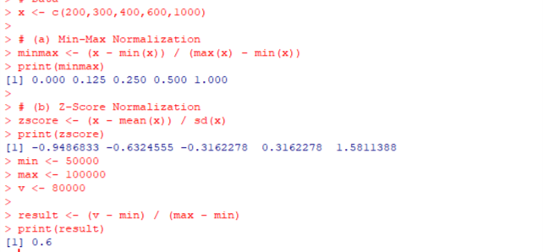
EXPERIMENT 5:
CODE:
# Load dataset
data(AirPassengers)
# Print dataset
print(AirPassengers)
# Histogram
hist(AirPassengers,
breaks = c(100,200,350,500,650,800),
main = "Histogram of AirPassengers",
xlab = "Passengers",
col = "lightblue")
# Print summary
summary(AirPassengers)

OUTPUT:
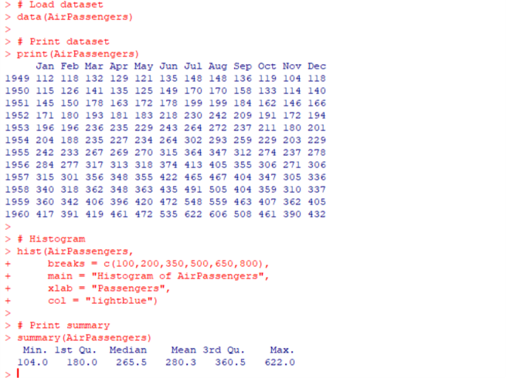
EXPERIMENT 6:
CODE:
# Load dataset
data(mtcars)
# Print first 10 values
print(mtcars[, c("mpg","qsec")])
# Plot first line
plot(mtcars$mpg,
type="l",
col="blue",
xlab="Car Number",
ylab="Value",
ylim=range(c(mtcars$mpg, mtcars$qsec)))
# Add second line
lines(mtcars$qsec, col="red")
# Add legend
legend("topright",
legend=c("mpg","qsec"),
col=c("blue","red"),
lty=1)
OUTPUT:
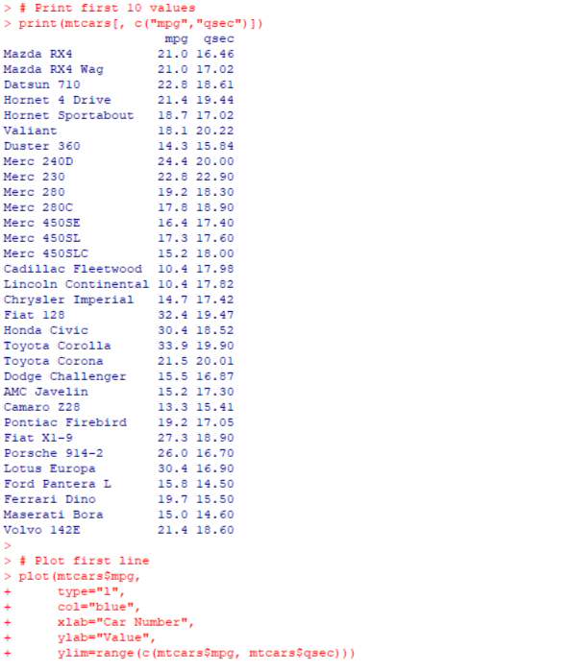
EXPERIMENT 8:
CODE:
# Load dataset
data(mtcars
# Print summary
print(summary(mtcars))
# Boxplot
boxplot(mpg ~ cyl,
data=mtcars,
main="MPG vs Cylinders",
xlab="Cylinders",
ylab="Miles Per Gallon",
col="lightgreen")
# Mean MPG for each cylinder
print(tapply(mtcars$mpg, mtcars$cyl, mean))
OUTPUT:
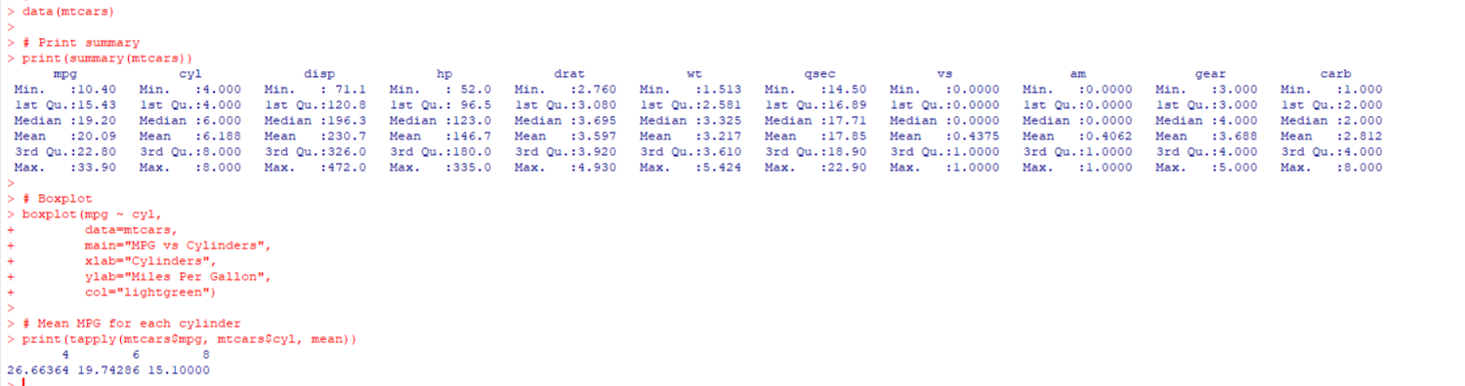

EXPERIMENT 9:
CODE:
# Player scores
score <- c(12,15,18,20,21,25,28,30,35,60)
# Print scores
print(score)
# Summary
print(summary(score))
# Boxplot
boxplot(score,
main="Tennis Player Scores",
ylab="Points",
col="orange")
# Find outliers
print(boxplot.stats(score)$out)
OUTPUT:
